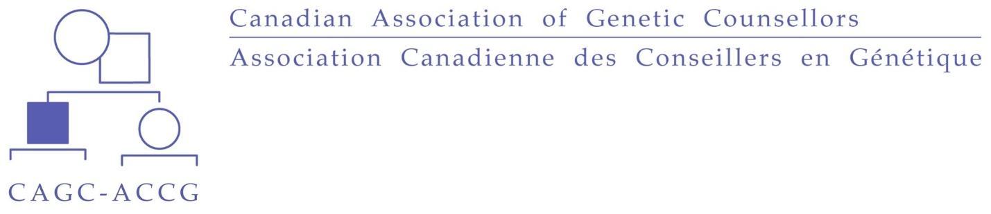
CAGC First Nations, Métis and Inuit Bursary for Canadian Genetic Counselling Applications
The Canadian Association of Genetic Counsellors (CAGC) is committed to fostering inclusion and diversity within the organization and the genetic counselling profession. Although five percent of the Canadian population identifies as First Nations, Métis or Inuit, these communities represent less than 1% of practicing genetic counsellors in this country. In 2015, the Truth and Reconciliation Commission of Canada called upon all levels of government to increase the number of Aboriginal professionals working in health-care fields. In alignment with this call to action, the CAGC is introducing an annual bursary for all Canadian citizens who self-identify as First Nations, Métis and Inuit, with the purpose of providing financial assistance towards applications to Canadian graduate programs in Genetic Counselling (McGill University, University of British Columbia, University of Manitoba, Université de Montreal, University of Toronto).
The First Nations, Métis and Inuit Bursary for Canadian Genetic Counselling is available annually. Eligible students may apply for reimbursement of application fees. Bursary applications must be received by May 31 of the same year of application. There is up to $3000 available annually and funding will be awarded in the order in which applications are received. Bursary recipients will be informed by email and will receive funds by e-transfer.
To apply for the bursary, please submit the following:
- Completed application form (Form 1)
- Attestation statement (Form 2)
- Proof of payment for program application and match program fees (scanned receipts, proof of payment emails, etc.)
Email completed applications to: ckaulback@cagc-accg.ca
If you have any questions about the bursary, eligibility criteria or the application process please contact Cammie Kaulback (ckaulback@cagc-accg.ca).
CAGC First Nations, Métis and Inuit Bursary for Canadian Genetic Counselling Applications
Bursary Application Form 1
Note: Before completing this form, please refer to the Bursary Information page for details regarding intent of the bursary, eligibility and supporting documentation required.
Demographic Information
Name (First Last): Click or tap here to enter text.
Email address (to be used for e-transfer of funds for bursary recipients)
Click or tap here to enter text.
Mailing Address: Click or tap here to enter text.
Phone number: Click or tap here to enter text.

MSc Genetic Counselling Program Information
Please check off each Canadian MSc Genetic Counselling program you have applied to and the amount paid:
☐ McGill University ($Click or tap here to enter text.)
☐ University of British Columbia ($ Click or tap here to enter text.)
☐ University of Manitoba ($ Click or tap here to enter text.)
☐ Université de Montreal ($ Click or tap here to enter text.)
☐ University of Toronto ($ Click or tap here to enter text.)
For each school applied to please include proof of payment of application fee (i.e., e-receipt) and proof of submission of application (i.e., confirmation email, screen shot of submission etc.).

Application Fees
Total application fee: $ Click or tap here to enter text.
National Matching Services Inc. Fee: $100 CAD
(Due to fluctuation of US to CAD funds a flat rate of $100 CAD will be reimbursed.)
Total: $ Click or tap here to enter text.

Optional Questions (to be used to help inform bursary communication/advertising in future)
How did you hear about this bursary?
☐CAGC website ☐ MSc GC Program website ☐Other: Click or tap here to enter text.
Did the availability of this bursary impact your decision to apply to the MSc Genetic Counselling programs in Canada? ☐Yes ☐ No

CAGC First Nations, Métis and Inuit Bursary for Canadian Genetic Counselling Applications
Bursary Declaration - Form 2
To be eligible for the CAGC First Nations, Métis and Inuit Bursary for Canadian Genetic Counselling Applications, a student must self-identify as an Indigenous person in Canada.
Indigenous and treaty rights of Indigenous peoples of Canada are recognized and affirmed in the Constitution Act of 1867 and 1982 (section 35). Section 35(2) indicates Indigenous peoples include First Nation (Status, Non-Status), Inuit and Métis peoples, recognizing that many people prefer the terms that are specific and traditional to their communities.
I attest that I identify as Indigenous as defined above and hereby declare that the information provided on this application is, to the best of my knowledge, true and complete. I authorize the release of the information contained herein to the Bursary Selection Committee.

Click or tap here to enter text. Click or tap here to enter text.
Name Signature

Click or tap to enter a date.
Date
The responses that you provide in this application will be kept confidential and stored in a secure location by the CAGC. Self-identification information will be used only for the purposes of providing the bursary and will not be shared with any other individual, group or institution, The name of a successful applicant will be released only with the expressed, written consent of the applicant.

