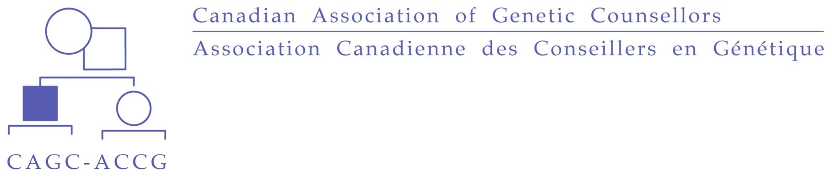

**CAGC MEMBERSHIP RENEWAL 2020/2021**

The CAGC membership year covers the period from July 1 to June 30 of the year that dues is paid, or at any point within the billing year until June 30 of that same year. Annual membership renewal takes place July 6 with early bird renewal closing July 20. There are no prorated dues rates.

Individuals who are eligible for membership *renewal* are any current members who wish to renew their membership during the annual renewal period. If you are a current Student member looking to renew as a Full member, please contact the CAGC Administrative office at [cagcoffice@cagc-accg.ca](mailto:cagcoffice@cagc-accg.ca). To take advantage of the early bird renewal discounted rate, **payments must be received on or before July 20, 2020**. Members (excluding students and Emeritus) renewing after the early renewal deadline must pay the full fee of $150 .

In accordance with Article 13 of the By-Laws of the Association, members who fail to pay annual dues within the time period designated by the Corporation shall be notified in writing of the default. Defaults not remedied within thirty (30) days of the notice shall result in automatic suspension of membership rights and privileges.

In accordance with Article 11 of the By-Laws, the following amount has been approved as the 2020/2021 membership fee:

|  |  |  |
| --- | --- | --- |
|  | **On or before July 20, 2020** | **After July 20, 2020** |
| **Full** | **$125** | **$150** |
| **Associate** | **$125** | **$150** |
| **Student** | **$40** | **$40** |
| **Emeritus** | **$65** | **$65** |

**If you would prefer to pay by credit card** [**click here**](https://www.cagc-accg.ca/?page=143) **to renew online.**

**Please complete the following:**

Note that your contact information will appear in the CAGC Membership Directory which is located in the Member-only area of our website. Please provide the information as you would like it to appear in the directory.

**Applicant’s Name:**

**Address:**

**Phone (home): Email:**

**Category of membership** (please check one): **Full____ Associate______ Student______ Emeritus______**

**In what areas do you practice** (check all that apply)

|  |  |  |  |  |  |
| --- | --- | --- | --- | --- | --- |
| Cancer |  | Metabolics |  | Pediatric |  |
| Cardiogenetics |  | Neurogenetics |  | Prenatal |  |
| Infertility/ART |  | Newborn Screening |  | Psychiatric genetics |  |
| Laboratory |  | Ocular Genetics |  | Genetic Counselors in non-clinical role |  |
| Other (indicate) |  | | | | |

**Employment:** Are you employed in genetic counselling? **Yes ___No___**

Name of current employer:

**Education:** Degrees completed in past 3 years (please include degree details and institution):

**Languages:**

Please list any language spoken fluently:

I am able to provide genetic counselling in French? **Yes__ No__**

French language translation services are available at the clinic where I work? **Yes__ No__**

**Please indicate what (if anything) has changed since your last renewal:**

|  |  |  |  |  |  |  |  |  |  |  |  |  |  |
| --- | --- | --- | --- | --- | --- | --- | --- | --- | --- | --- | --- | --- | --- |
| **Name** |  | **Address** |  | **Phone/fax** |  | **Email** |  | **Member Category** |  | **Area of Practice** |  | **Employer** |  |

Would you be willing to be contacted by the Board of Directors with questions related to your area(s) of practice?

**Yes____ No____**

If yes, which areas of practice?

|  |  |  |  |  |  |
| --- | --- | --- | --- | --- | --- |
| Cancer |  | Metabolics |  | Pediatric |  |
| Cardiogenetics |  | Neurogenetics |  | Prenatal |  |
| Infertility/ART |  | Newborn Screening |  | Psychiatric genetics |  |
| Laboratory |  | Ocular Genetics |  | Genetic Counselors in non-clinical role |  |
| Other (indicate) |  | | | | |

**Communities of Practice**

The CAGC Board of Directors (BoD) has developed 7 Communities of Practice with the idea of connecting counsellors with expertise in a given area to act as a network across the country and as a resource to one another. The CAGC BoD may ask a CoP to undertake a project of value to the entire CAGC membership (e.g., patient education materials, practice guidelines). Alternatively, a CoP can initiate such a project themselves. There is no obligation to participate in projects as a member of a CoP.

If you are interested in joining any of the CoPs, please contact the leaders directly by email.

|  |  |  |
| --- | --- | --- |
| **CoP** | **Lead(s)** | **Email** |
| **Cancer** | Jeanna McCuaig | jeanna.mccuaig@uhn.ca |
| **Neurogenetics** | Claire Goldsmith | goldsmith@cheo.on.ca |
| **Newborn Screening/Metabolics** | Jessica Hartley  Sara Fernandez | jessica.hartley@umanitoba.ca  sara.fernandez@easternhealth.ca |
| **Non-clinical**  (including education, industry and research) | Leichelle Little  Katy Skora | llittle5@uwo.ca  katyskora1@gmail.com |
| **Prenatal** | Hana Sroka | hanaksroka@gmail.com |
| **Psychiatric genetics** | Angela Inglis | angela.inglis@ubc.ca |

**Please make cheques payable to Canadian Association of Genetic Counsellors** and mail, along with renewal form, to the CAGC Administrative Office:

**CAGC Head Office Telephone: (905) 847-1363**

**PO Box 52083 Email:** [**cagcoffice@cagc-accg.ca**](mailto:cagcoffice@cagc-accg.ca)

**Oakville, Ontario**

**Canada L6J 7N5**